Project Report Template

INDIA’S AGRICULTURE CROP PRODUCTION

1 INTRODUCTION

1.1 Overview

A brief description about your project

Agriculture is the practice of cultivating plants and livestock in order to provide facilities to human beings. In the rise of the sedentary human lifestyle agriculture was the key development. The cultivation of plant and food grains began years ago in order to provide food to the city population. Agriculture is the main need for the people to live in the society. Agriculture is the main source of livelihood, it provides a source for the people to earn. Most of the population in the rural areas is dependent on agriculture as their main source of income.

1.2 Purpose

The use of this project. What can be achieved using this.

We don’t have any idea about agriculture before this project. Now we are talk about this session and we got surprise about statistical points from India’s Agriculture. We were know how to use tableau and other websites. It was very useful for our students.

2 Problem Definition & Design Thinking

2.1 Empathy Map

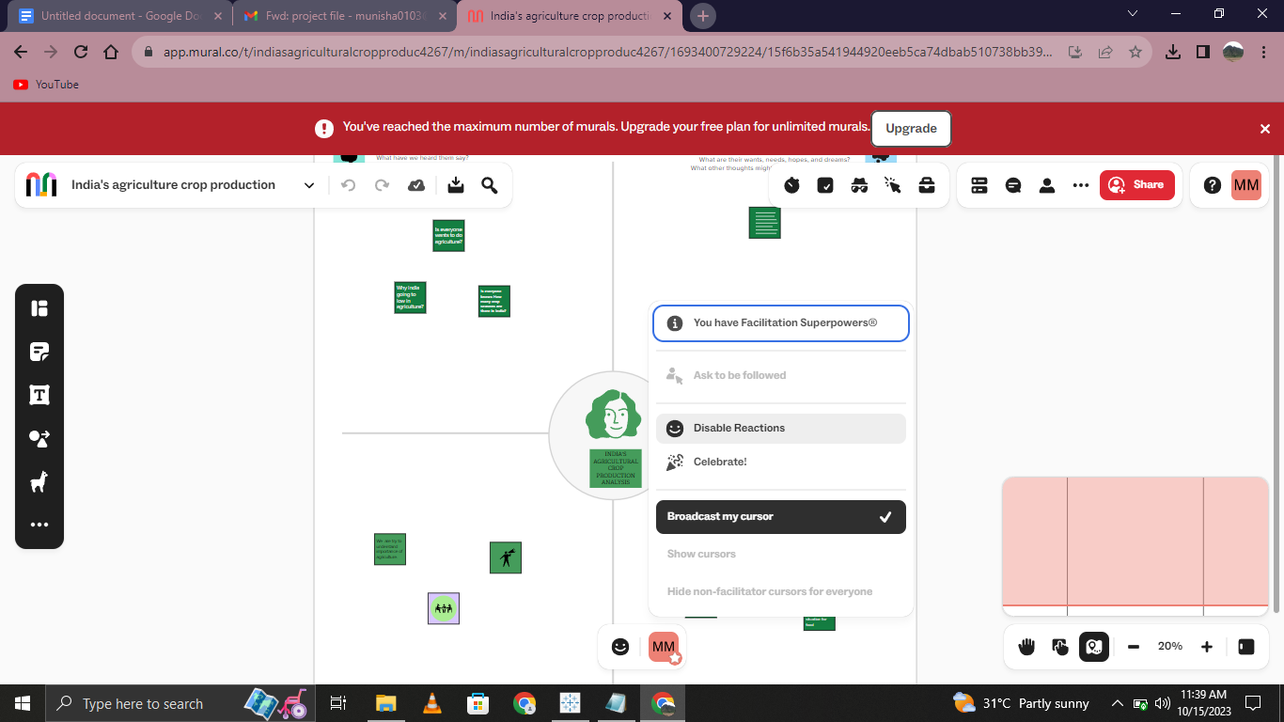

2.2 Ideation & Brainstorming Map

Paste the Ideation & brainstorming map screenshot

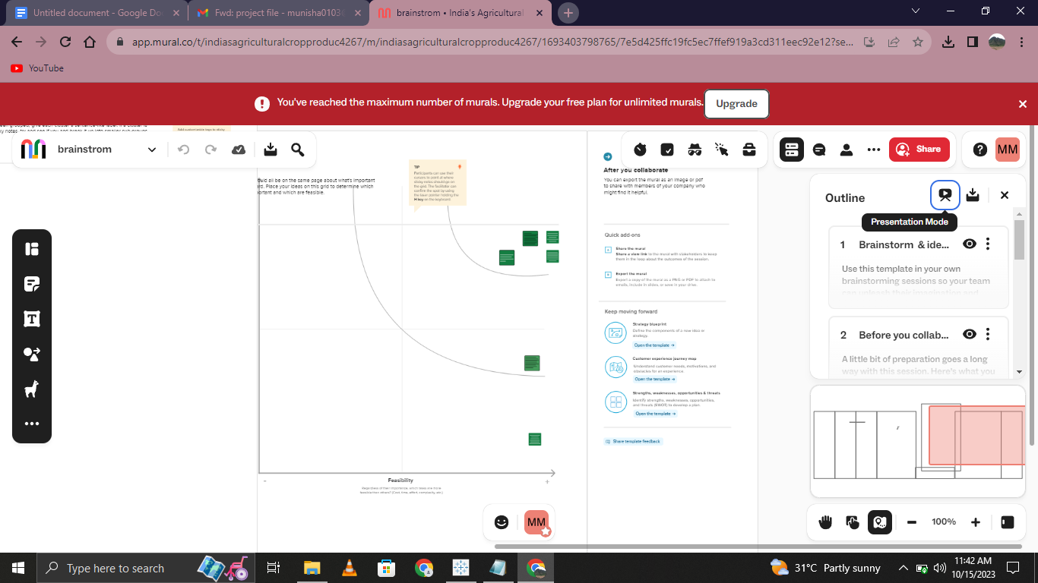

3 RESULT

Final findings (Output) of the project along with screenshots.

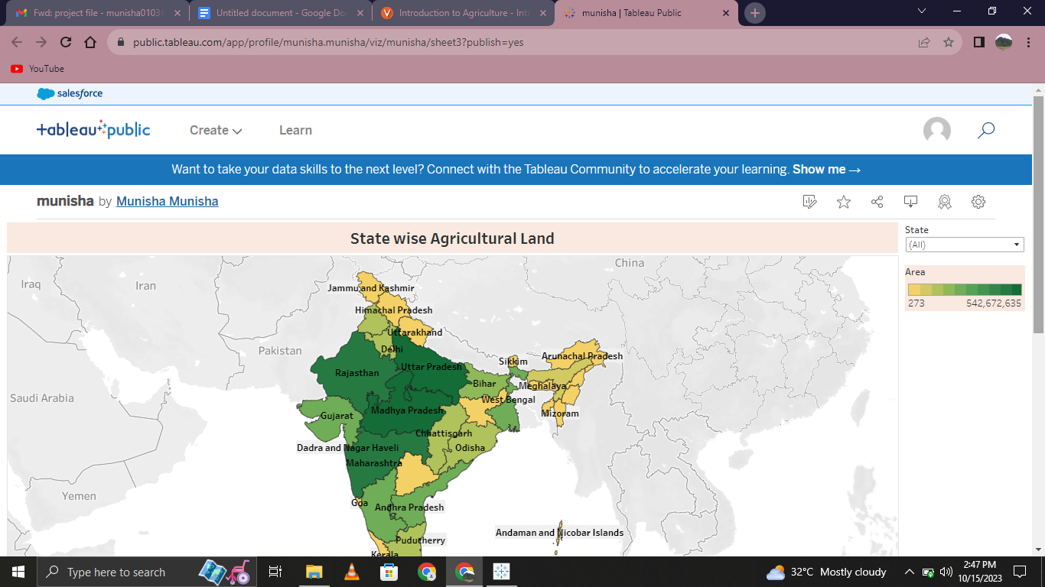

4 ADVANTAGES

Modern farming methods are more efficient than traditional methods, with advanced machinery and equipment, allowing farmers to produce larger quantities of crops in less time and with less labour

DISADVANTAGES

Modern agriculture can have a negative impact on biodiversity, with the use of monoculture and genetically modified crops leading to a loss of natural diversity in plant and animal species.

5 APPLICATIONS

The areas where this solution can be applied

Human beings need agriculture. So wherever we do production of foods.

6 CONCLUSION

Conclusion summarising the entire work and findings

All kinds of technology is a key to making everything. But that doesn't save human beings. We must be clear about that. Save agriculture.

7 FUTURE SCOPE

Enhancements that can be made in the future.

Present, past, future agriculture must be saved by humans.

8 APPENDIX

A. Source Code

Attach the code for the solution built.